Lab – 5

Temperature & Humidity Monitoring using DHT Sensor
1. Aim
To interface a DHT sensor with Arduino and measure temperature and humidity.

2. Theory
DHT11 is a digital sensor used to measure environmental temperature and humidity.
Features:
- Low cost
- Digital signal output
- Easy interfacing with Arduino
The sensor sends data serially to the microcontroller.

3. Apparatus / Requirements
- Arduino Uno
- DHT11
- Breadboard
- Jumper wires
- USB cable
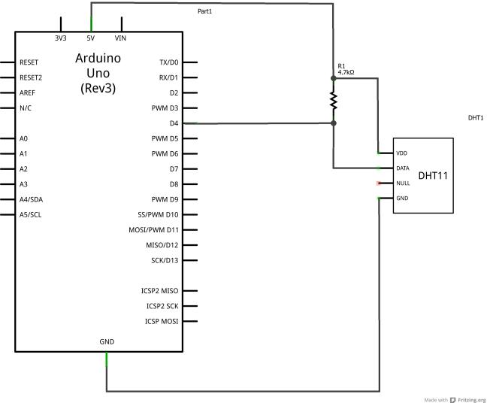
- Arduino IDE

4. Circuit Diagram

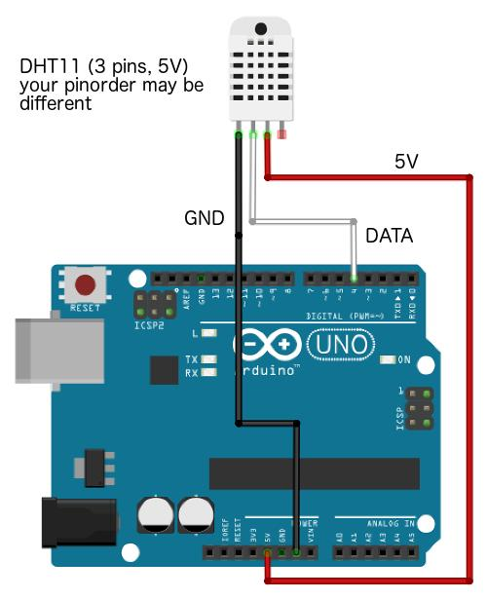

⚙️

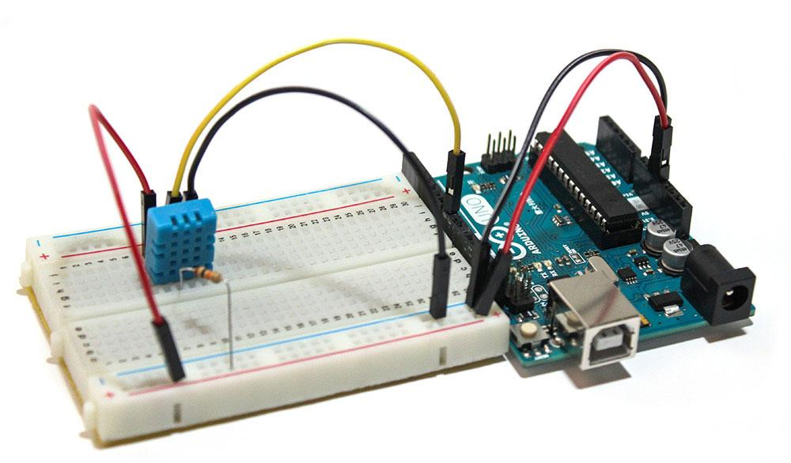

5. Procedure
- Connect DHT sensor to Arduino
- Install DHT sensor library
- Write Arduino program
- Upload code to board
- Open Serial Monitor
- Observe temperature and humidity readings

- Program / Code

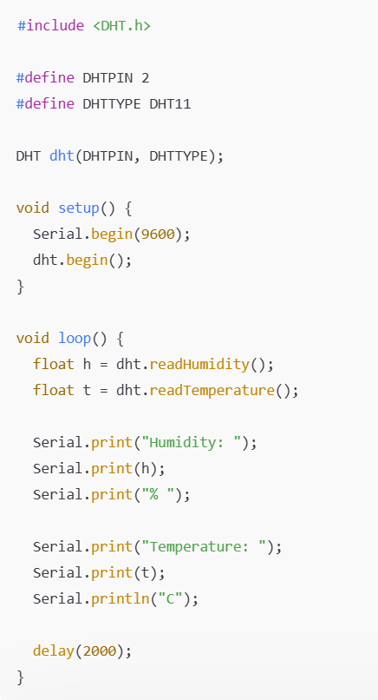

7. Observations / Readings
Temperature | Humidity
30°C | 65%
31°C | 66%

8. Result
Temperature and humidity were successfully measured using the DHT sensor.

